# Risk Analysis using Multi agents

Risk Analysis using Multi agents 1

Introduction 2

# Introduction

In today's rapidly evolving financial landscape, risk management has become more complex than ever. From facing huge volumes of data to sophisticated ways of fraud, and ever-changing requirements in regulation, the traditional approaches toward risk management grow weak inside any financial institution. This gives rise to AI-driven multi-agent systems, in which technologies like Akira AI redefine risk management and mitigation within an organization. The blog describes AI agents as agents of change in risk analytics and features a state-of-the-art solution developed by Akira AI.

# What are AI Agents?

AI agents are computer programs that are designed to carry out tasks independently by making decisions based on their environment, input, and some set objectives. Unlike conventional automation systems that strictly follow predefined instructions, AI agents can think, adapt, and act on their own. They are configured to evaluate their surroundings, learn from past experiences, and make decisions to accomplish specific goals.

AI agents can vary from basic program performing single tasks to sophisticated systems managing complex processes. They excel in unpredictable environments and utilize their learning capabilities to navigate the internet, interact with applications, process enormous amounts of data and engage in transactions along with refining their methods on the feedback.

# AI Agents in Risk Analysis

Risk analysis involves evaluating the potential risks that could negatively impact an organization. Traditionally, this process has been manual, time-consuming, and prone to human error. However, AI agents can transform risk analysis by automating key processes, ensuring accuracy, speed, and compliance. These agents can analyze vast amounts of data in real-time, assess risks using advanced machine learning models, and monitor compliance with regulatory standards. The result is a more efficient and proactive approach to risk management.

# Challenges Faced in Risk Analysis

Financial institutions face several challenges in risk analysis, including:

## How AI Agents Address These Challenges

AI agents offer several solutions to the challenges mentioned above:

Manual time consuming:

* **Automation:** By automating processes such as data collection, risk scoring, and compliance monitoring, AI agents reduce the time and effort required, minimizing errors and increasing efficiency.
* **Real-Time Analysis:** AI agents can analyze data in real-time, quickly identifying anomalies and potential fraud, which allows for faster response times.
* **Regulatory Compliance:** Continuous monitoring by AI agents ensures that all activities are compliant with current regulations, reducing the risk of penalties.
* **Data Security:** AI-driven systems are designed with advanced security features to protect sensitive data from unauthorized access and breaches.

# Akira AI's Solution to Risk Analysis

Akira AI leverages a multi-agent system to provide a comprehensive solution to risk analysis. The architecture is designed to orchestrate various specialized agents that handle different aspects of risk management, ensuring a seamless and efficient workflow. The Master Orchestrator Agent coordinates tasks across the system, utilizing both a large language model (LLM) and a knowledge graph to optimize decision-making processes.

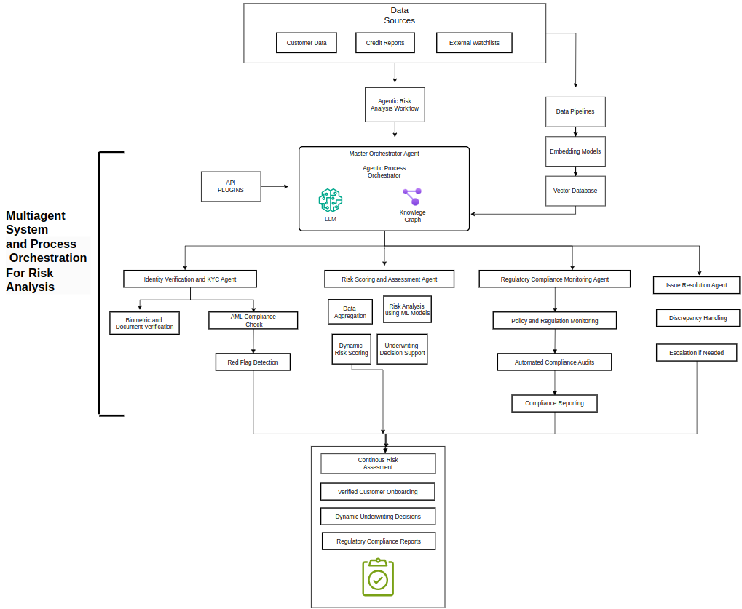 Figure : Risk analysis

## Process Flow

The process begins with the **Master Orchestrator Agent**, which oversees the entire workflow, integrating inputs from various data sources such as customer data, credit reports, and external watchlists. The data is processed through multiple agents, each specializing in a different aspect of risk analysis:

1. **Data Sources and Pipelines:** Raw data from various sources is fed into the system, where it undergoes processing through data pipelines, embedding models, and vector databases to prepare it for analysis.
2. **Identity Verification and KYC Agent:** This agent performs identity verification, biometric checks, and Anti-Money Laundering (AML) compliance checks. It flags potential risks early in the process through red flag detection.
3. **Risk Scoring and Assessment Agent:** This agent aggregates data and utilizes machine learning models to dynamically score risks and support underwriting decisions.
4. **Regulatory Compliance Monitoring Agent:** This agent continuously monitors policy and regulation changes, conducts automated compliance audits, and generates compliance reports.
5. **Issue Resolution Agent:** Handles discrepancies in real-time and escalates issues when necessary.
6. **Continuous Risk Assessment:** The system offers ongoing risk assessment, dynamic underwriting decisions, and continuous compliance reporting, ensuring that the organization is always in line with regulatory standards.

## Tech Stack Used

Akira AI’s solution is built using advanced technologies such as:

* **Large Language Models (LLMs):** For processing and understanding complex data.
* **Knowledge Graphs:** To map relationships between different data points and provide context-aware decision-making.
* **Machine Learning Models:** For risk scoring and fraud detection.
* **API Integrations:** To connect with external data sources and other systems.
* **Embedding Models and Vector Databases:** For efficient data storage and retrieval.

## Multi-Agent System in Action

The multi-agent system in Akira AI operates autonomously, ensuring that each component of risk analysis is handled efficiently. The system's ability to operate in real-time, coupled with its advanced machine learning models, allows it to provide proactive risk management. The agents work collaboratively, sharing insights and coordinating actions to achieve comprehensive risk mitigation.

## Comparison of Traditional AI Solutions with Akira AI Solution for Risk Analysis

Traditional AI solutions in risk analysis often focus on isolated tasks such as fraud detection or compliance monitoring. However, these solutions lack the integration and autonomy offered by Akira AI's multi-agent system. Akira AI not only automates individual tasks but also orchestrates them across a unified platform, ensuring that all aspects of risk management are aligned and optimized. This leads to higher accuracy, faster decision-making, and better regulatory compliance compared to traditional solutions.

## Key Benefits

Akira AI’s risk analysis solution offers several key benefits:

* **Increased Accuracy:** Automation reduces human error, improving the reliability of risk assessments.
* **Faster Decision-Making:** Real-time data analysis speeds up processes like onboarding and underwriting.
* **Enhanced Compliance:** Continuous monitoring ensures 100% adherence to regulatory standards.
* **Proactive Risk Management:** Early detection of risks allows for quicker mitigation.
* **Cost Savings:** By reducing manual labor and minimizing errors, the system delivers significant cost savings.

# Conclusion

The integration of AI agents in risk analysis represents a significant leap forward in how financial institutions manage risk. Akira AI’s multi-agent system provides a comprehensive, autonomous, and proactive solution that addresses the challenges of traditional risk management methods. By leveraging advanced technologies and orchestrating specialized agents, Akira AI ensures that financial organizations can operate securely and efficiently in a complex regulatory environment.

This solution not only improves the accuracy and speed of risk assessments but also enhances overall organizational efficiency, making it a valuable asset for any institution facing the challenges of modern risk management.